WEEK 5

ASP.NET Core 8.0 Web API-6. WebApi_Handson

FruitsController6.cs

using Microsoft.AspNetCore.Mvc;

namespace WebApi_Handson1.Controllers
{
[ApiController]
[Route("api/[controller]")]
public class FruitsController6 : ControllerBase
{
private static List<string> fruits = new List<string>
{
"Apple", "Banana", "Mango", "Grapes", "Avocado", "Pineapple", "Papaya", "Guava"
};

// GET: api/FruitsController6
[HttpGet]
public IActionResult GetAllFruits([FromQuery] string? sort, [FromQuery] int? page, [FromQuery] int? pageSize)
{
var result = fruits.AsEnumerable();

// Sorting
if (!string.IsNullOrEmpty(sort))
{
result = sort.ToLower() == "desc" ? result.OrderByDescending(f => f) : result.OrderBy(f => f);
}

// Pagination
if (page.HasValue && pageSize.HasValue)
{
result = result.Skip((page.Value - 1) * pageSize.Value).Take(pageSize.Value);
}

return Ok(result);
}

// GET: api/FruitsController6/search?name=app
[HttpGet("search")]
public IActionResult SearchFruits([FromQuery] string name)
{
var filtered = fruits.Where(f => f.ToLower().Contains(name.ToLower())).ToList();

if (filtered.Count == 0)
return NotFound("No matching fruits found.");

return Ok(filtered);
}

// GET: api/FruitsController6/throw
[HttpGet("throw")]
public IActionResult ThrowTestError()
{
throw new Exception("This is a test exception for global error handling.");
}
}
}

SCREENSHOTS-

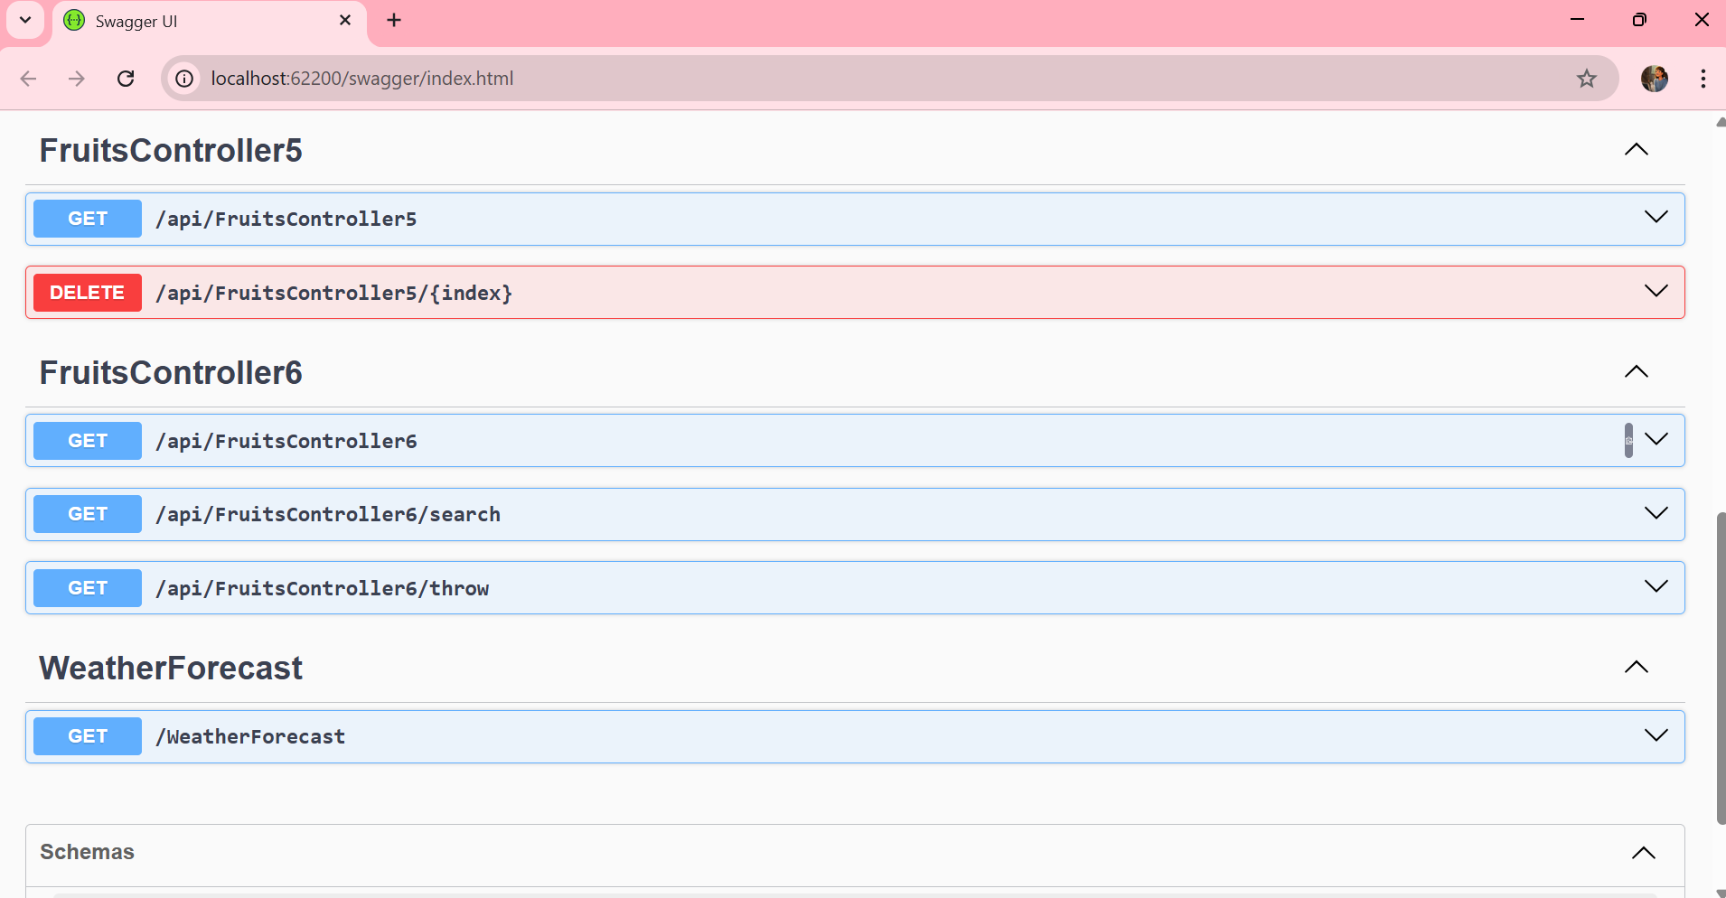
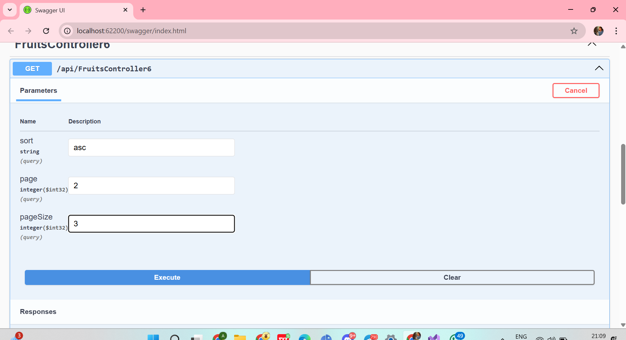
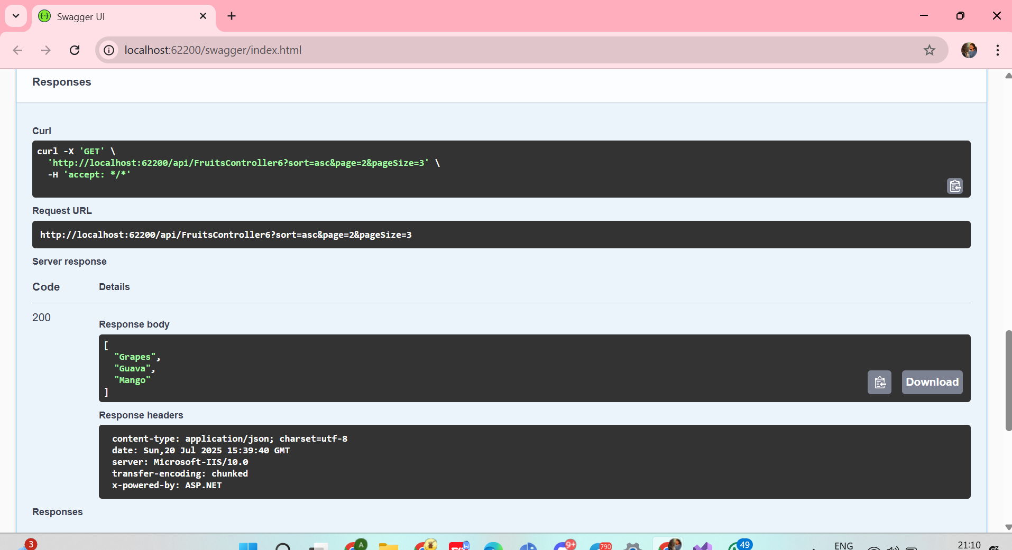
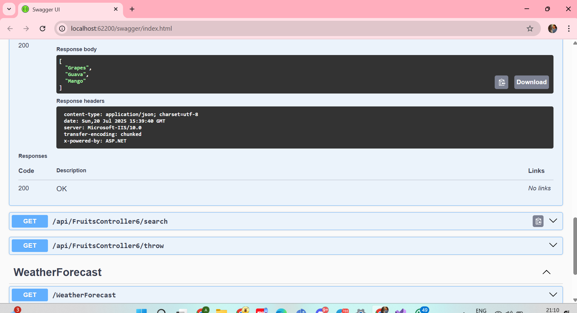
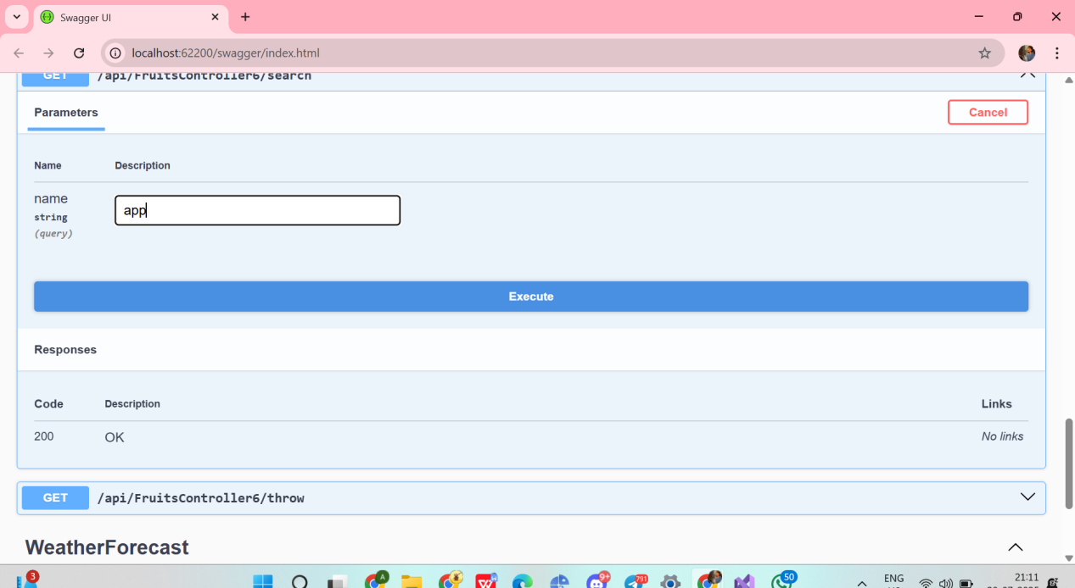
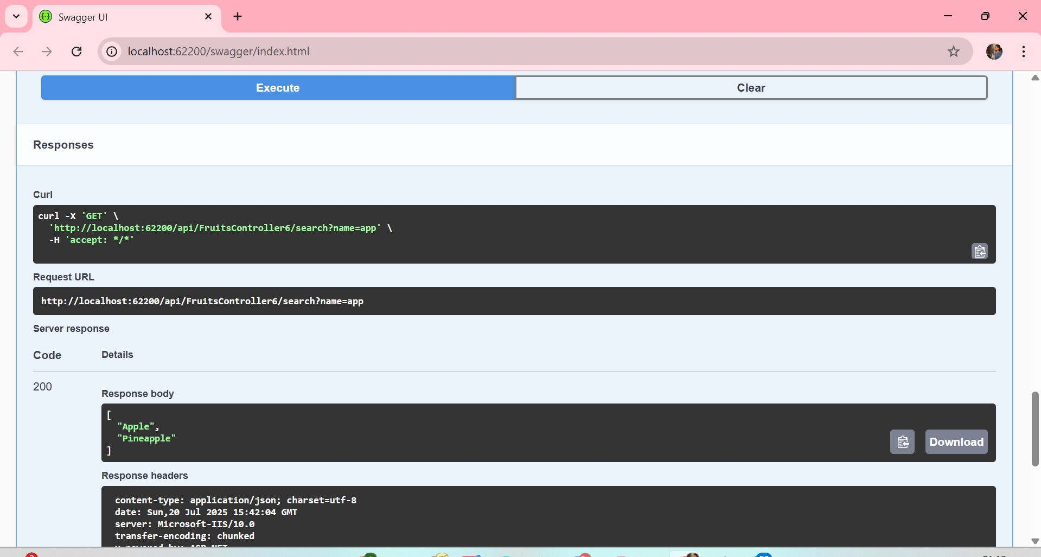
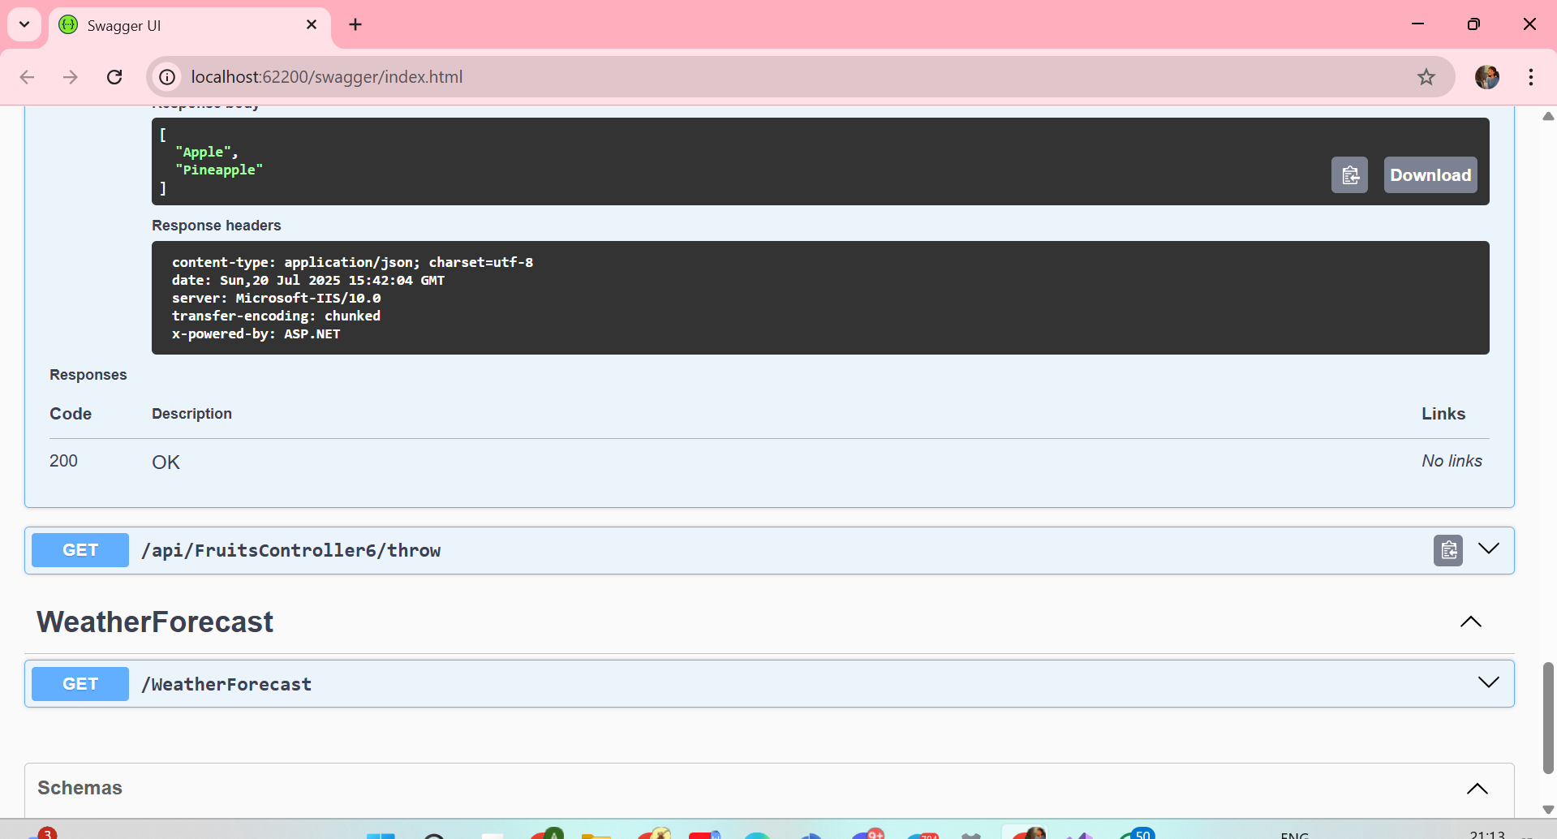
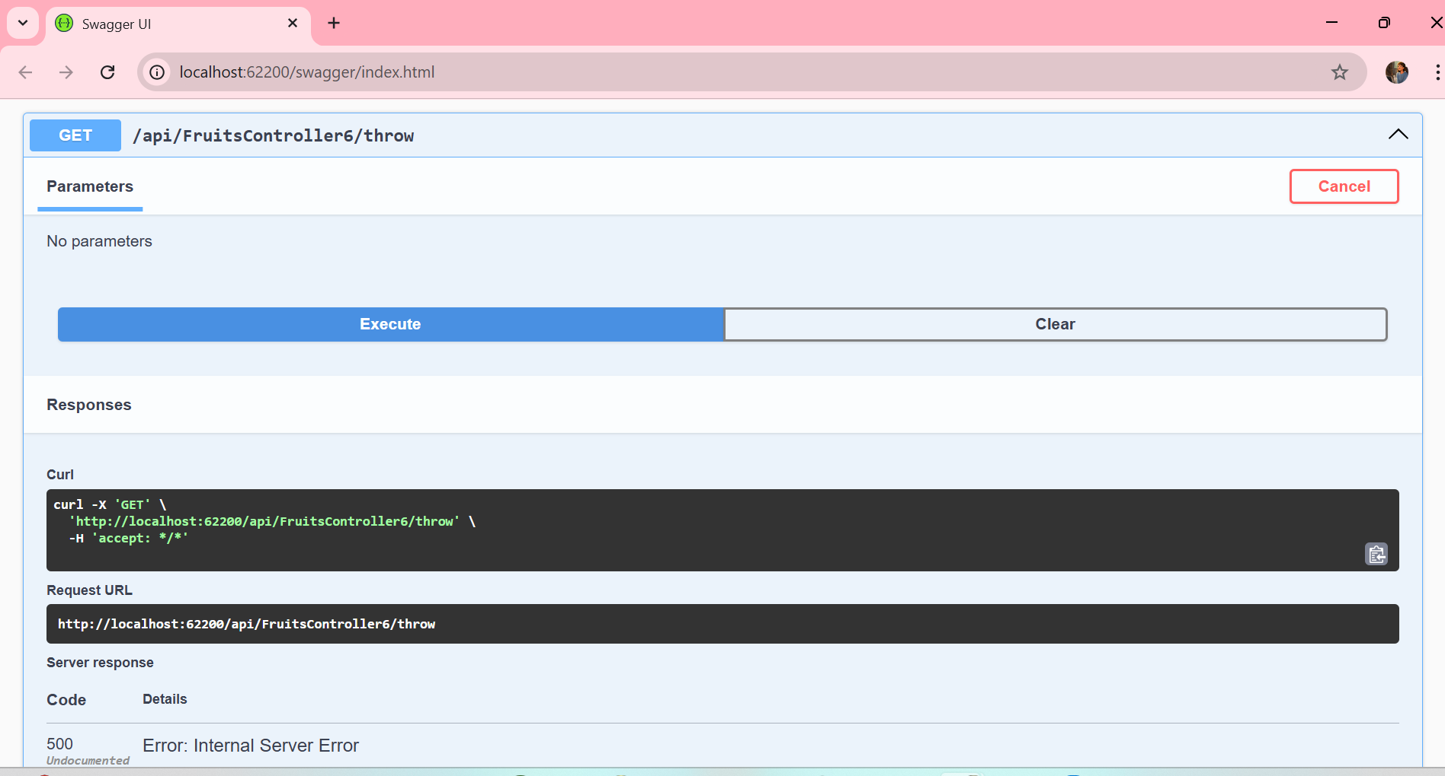
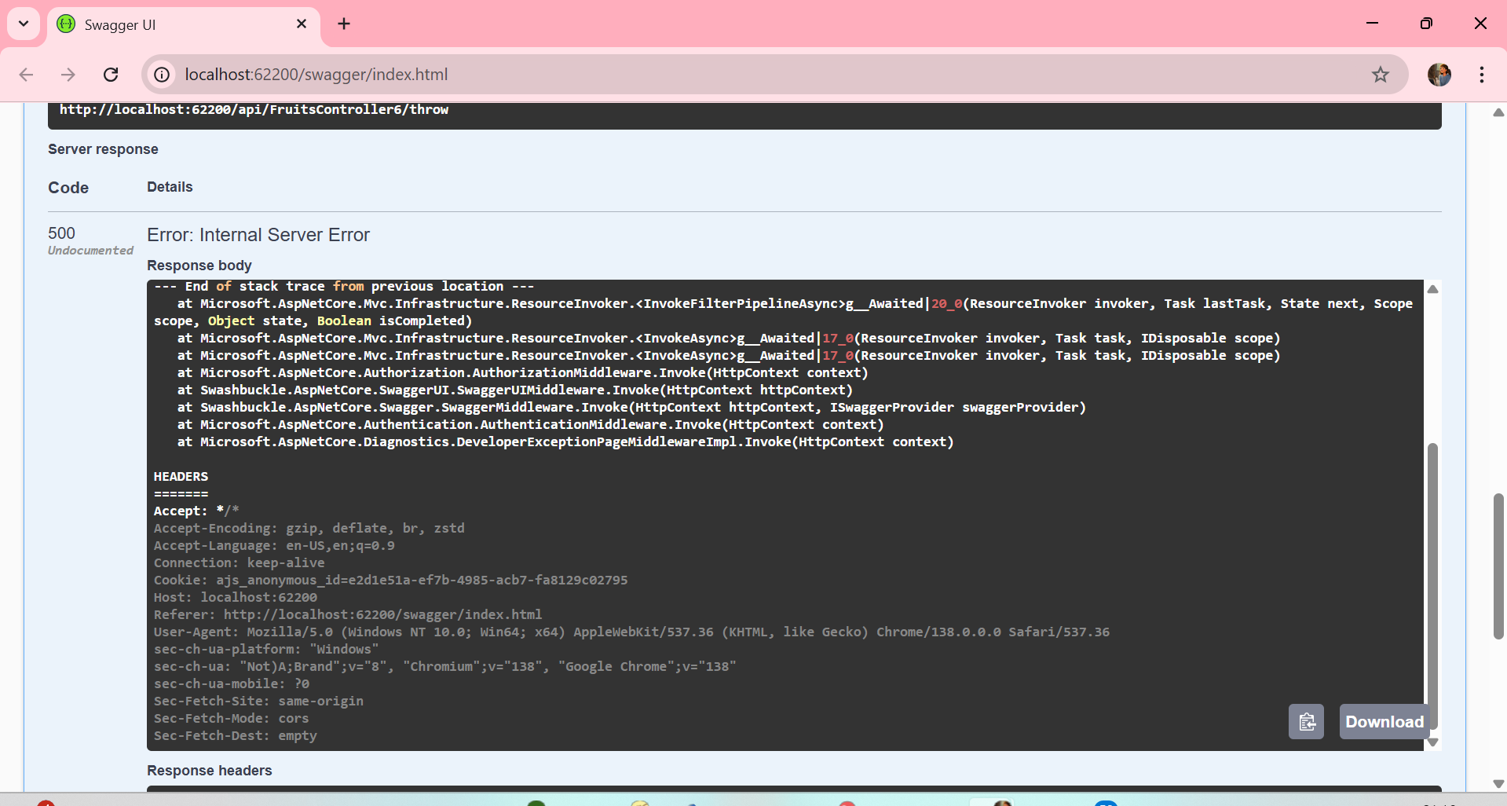
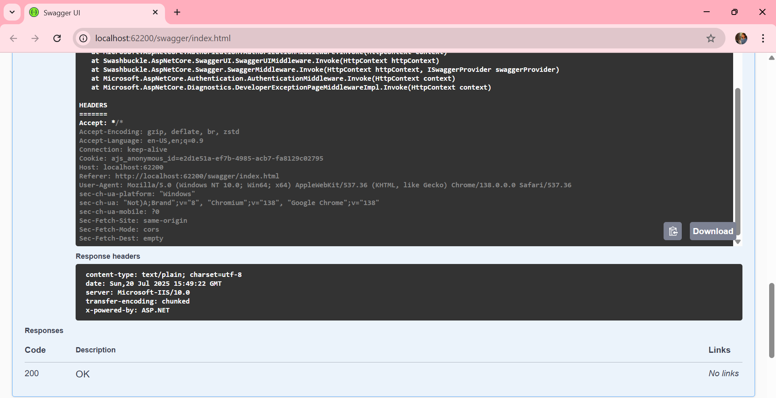

Microservices Architecture using ASP.NET Core Web API

TASK 1-

AuthController.cs
using Microsoft.AspNetCore.Mvc;
using Microsoft.IdentityModel.Tokens;
using System.IdentityModel.Tokens.Jwt;
using System.Security.Claims;
using System.Text;
using Microservices_JwtAuth.Models;

namespace Microservices_JwtAuth.Controllers
{
[ApiController]
[Route("api/[controller]")]
public class AuthController : ControllerBase
{
private readonly IConfiguration _configuration;

public AuthController(IConfiguration configuration)
{
_configuration = configuration;
}

[HttpPost("login")]
public IActionResult Login([FromBody] UserModel user)
{
if (user.Username == "admin" && user.Password == "admin")
{
var token = GenerateJwtToken(user);
return Ok(new { token });
}

return Unauthorized("Invalid credentials");
}

private string GenerateJwtToken(UserModel user)
{
var issuer = _configuration["Jwt:Issuer"];
var audience = _configuration["Jwt:Audience"];
var keyString = _configuration["Jwt:Key"] ?? throw new ArgumentNullException("JWT Key missing");
var key = Encoding.UTF8.GetBytes(keyString);

var claims = new[]
{
new Claim(JwtRegisteredClaimNames.Sub, user.Username),
new Claim(JwtRegisteredClaimNames.Jti, Guid.NewGuid().ToString())
};

var credentials = new SigningCredentials(new SymmetricSecurityKey(key), SecurityAlgorithms.HmacSha256);

var token = new JwtSecurityToken(
issuer: issuer,
audience: audience,
claims: claims,
expires: DateTime.UtcNow.AddMinutes(60),
signingCredentials: credentials
);

return new JwtSecurityTokenHandler().WriteToken(token);
}
}
}

SecureController.cs

using Microsoft.AspNetCore.Authorization;
using Microsoft.AspNetCore.Mvc;

namespace Microservices_JwtAuth.Controllers
{
[ApiController]
[Route("api/[controller]")]
public class SecureController : ControllerBase
{
[Authorize]
[HttpGet("data")]
public IActionResult GetSecureData()
{
var user = User.Identity?.Name ?? "Unknown";
return Ok($"Hello {user}, this is protected data only visible with a valid token.");
}
}
}

UserModel.cs

namespace Microservices_JwtAuth.Models
{
public class UserModel
{
public string Username { get; set; } = string.Empty;
public string Password { get; set; } = string.Empty;
}
}

appsettings.json

{
"Logging": {
"LogLevel": {
"Default": "Information",
"Microsoft.AspNetCore": "Warning"
}
},
"AllowedHosts": "*",
"Jwt": {
"Key": "this is my custom Secret key for auth",
"Issuer": "yourapp",
"Audience": "yourappusers"
}
}

Program.cs

using Microsoft.AspNetCore.Authentication.JwtBearer;
using Microsoft.IdentityModel.Tokens;
using Microsoft.OpenApi.Models;
using System.Text;

var builder = WebApplication.CreateBuilder(args);

// 1. Add controllers
builder.Services.AddControllers();

// 2. Swagger + JWT setup
builder.Services.AddEndpointsApiExplorer();
builder.Services.AddSwaggerGen(options =>
{
// Add JWT Auth to Swagger
options.AddSecurityDefinition("Bearer", new OpenApiSecurityScheme
{
Name = "Authorization",
Type = SecuritySchemeType.ApiKey,
Scheme = "Bearer",
BearerFormat = "JWT",
In = ParameterLocation.Header,
Description = "Enter 'Bearer' [space] and then your valid token.\n\nExample: \"Bearer eyJhbGciOi...\""
});

options.AddSecurityRequirement(new OpenApiSecurityRequirement
{
{
new OpenApiSecurityScheme
{
Reference = new OpenApiReference
{
Type = ReferenceType.SecurityScheme,
Id = "Bearer"
}
},
new string[] {}
}
});
});

// 3. JWT Authentication config
builder.Services.AddAuthentication(JwtBearerDefaults.AuthenticationScheme)
.AddJwtBearer(options =>
{
options.TokenValidationParameters = new TokenValidationParameters
{
ValidateIssuer = true,
ValidateAudience = true,
ValidateLifetime = true,
ValidateIssuerSigningKey = true,
ValidIssuer = builder.Configuration["Jwt:Issuer"],
ValidAudience = builder.Configuration["Jwt:Audience"],
IssuerSigningKey = new SymmetricSecurityKey(
Encoding.UTF8.GetBytes(builder.Configuration["Jwt:Key"]!))
};
});

var app = builder.Build();

// 4. Configure middleware
if (app.Environment.IsDevelopment())
{
app.UseSwagger();
app.UseSwaggerUI();
}

app.UseHttpsRedirection();

// Add authentication and authorization
app.UseAuthentication();
app.UseAuthorization();

app.MapControllers();

app.Run();

